Section 1: Case Summary

Scenario Title: | COPDe with Massive Hemoptysis
Keywords: | Hemoptysis, Bronchiectasis, Intubation, Anticoagulation, COPD Exacerbation
Brief Description of Case: | This is a case of a 57-year-old male with former smoking history, COPD on home O2, atrial fibrillation on anticoagulation coming into a community emergency department (ED) with symptoms consistent with COPD exacerbation. His initial presentation will respond to traditional therapies for COPD exacerbation and positive pressure ventilation. During his ED stay, however, the patient will develop a coughing fit and hemoptysis with airway compromise, requiring learners to secure the airway, reverse anticoagulation, and manage massive hemoptysis.

Goals and Objectives
Educational Goal: | Recognize massive hemoptysis as an airway emergency with effective airway securement plan and adjunct management
Objectives:  (Medical and CRM) | - Recognize decompensation of patient and need for definitive airway  - Convey priorities and plan of airway securement via shared mental model with team members  - Recognize life threatening bleeding and reverse anticoagulation  - Consultation of appropriate specialists for continued management of massive hemoptysis

Learners, Setting and Personnel
Target Learners: | ☐ Junior Learners |  | ☒ Senior Learners |  |  | ☒ Staff
 | ☒ Physicians | ☒ Nurses |  | ☒ RTs | ☒ Inter-professional
 | ☒ Other Learners: Anesthesia
Location: | ☒ Sim Lab |  | ☒ In Situ |  |  | ☐ Other:
Recommended Number of Facilitators: | Instructors: 1
 | Sim Actors: 2 (Nurse and RT)
 | Sim Techs: 1

Scenario Development
Date of Development: | 2/2/2022
Scenario Developer(s): | Alex Koo, MD, CHSE
Affiliations/Institutions(s): | Madigan Army Medical Center
Contact E-mail: | Koo.alex@gmail.com
Version Number: | 1.0

Section 2A: Initial Patient Information

- Patient Chart
Patient Name: Jackson Boggard |  |  |  | Age: 57 | Gender: Male | Weight: 100 kg
Presenting complaint: Cough and shortness of breath
Temp: 38.1 C | HR: 124 bpm | BP: 162/94 |  | RR: 22 | O₂Sat: 90% | FiO₂: 3L NC
Cap glucose (if asked): 7.3 |  |  |  | GCS: 15
Triage note:

Per EMS Report: Patient called EMS c/o SOB and cough, progressively worsening over the last three days. The patient is coming from home, where he was found sitting in his couch in mild respiratory distress.

The patient is brought to your resuscitation room.

Allergies: NKDA
Past Medical History:  COPD (3 L NC at home)  HTN  HLD  Atrial Fibrillation  Hx of smoking 2 pack per day x 25 years  Received COVID vaccination and booster |  |  | Current Medications:  Fluticasone with Salmeterol 115 mcg/21 mcg HFA  Albuterol HFA  Amlodipine 5 mg  Atorvastatin 40 mg  Warfarin 5 mg

Section 2B: Extra Patient Information

A. Further History
Include any relevant history not included in triage note above. What information will only be given to learners if they ask? Who will provide this information (mannequin’s voice, sim actors, SP, etc.)?
- Patient is normally on 3 L NC at home
- Cough has been more productive of green sputum over the last 2 days
- Hospitalized for COPD exacerbation three times in the last year, but no history of intubation or ICU stay.
- INR check three days prior was 2.3
- Patient only feels short of breath when coughing fits or moving around the home
- No history of PE/DVT, no recent travel, no sick contacts
B. Physical Exam
List any pertinent positive and negative findings
Cardio: -CP | Neuro: - HA, dizziness
Resp: +SOB, +Cough, +Wheezing | Head & Neck: +Rhinorrhea, - Sore Throat
Abdo: -Abdominal Pain, - n/v/d | MSK/skin: -Rashes
Other: No leg swelling, paroxysmal nocturnal dyspnea, orthopnea

Section 3: Technical Requirements/Room Vision

A. Patient
☒ Mannequin Adult
☐ Standardized Patient
☐ Task Trainer
☐ Hybrid
B. Special Equipment Required
Standard supplemental oxygen supplies
CPAP or BiPAP
Ventilator
Intubation supplies
Cricothyrotomy Kit
Suction Canister, suction tubing, and Yankauer
Ultrasound

C. Required Medications
Albuterol/Ipratropium
Steroid (i.e. methylprednisolone, prednisone, hydrocortisone)
Antibiotics – Levofloxacin, Ceftriaxone, Cefotaxime
Magnesium
Vitamin K
4 Factor Prothrombin Complex Concentrate (PCC)
Fresh Frozen Plasma (FFP)
Transexamic acid (TXA)
Isotonic fluids (i.e. Normal Saline, Lactated Ringers, Plasmalyte)
Packed Red Blood Cells
RSI medications

D. Moulage
Diaphoretic (spray manikin)

E. Monitors at Case Onset
☒ Patient on monitor with vitals displayed
☐ Patient not yet on monitor
F. Patient Reactions and Exam
Include any relevant physical exam findings that require mannequin programming or cues from patient
(e.g. – abnormal breath sounds, moaning when RUQ palpated, etc.) May be helpful to frame in ABCDE format.
A) Coughing, but speaking full sentences on initial presentation
B) Wheezing in all lung fields
C) Rapid and irregular, bounding pulse
D) GCS 15, moving 4 x extremities

Section 4: Sim Actor and Standardized Patients

Sim Actor and Standardized Patient Roles and Scripts
Role | Description of role, expected behavior, and key moments to intervene/prompt learners. Include any script required (including conveying patient information if patient is unable)
Bedside ED Nurse | Assist with starting IVs, drawing labs, giving medications, updating changes in vitals. Skilled and helpful.
Respiratory Therapy | Assist with ABG, intubation, and ventilator set-up. Skilled and helpful.

Section 5: Scenario Progression

Scenario States, Modifiers and Triggers
Patient State/Vitals | Patient Status | Learner Actions, Modifiers & Triggers to Move to Next State |  | Facilitator Notes
1. Baseline State  Rhythm: Atrial Fibrillation  HR: 124 bpm  BP: 164/92  RR: 24  O₂SAT: 90% (3L NC)  T: 38.1 ºC  GCS: 15 | Coughing, speaking full sentences in mild respiratory distress with tachypnea and audible wheezing. | Expected Learner Actions  Establish IVs x 2  Consider PPV/HFNC  Draw labs, blood cultures  EKG  Salbutamol/ipratropium  Corticosteroid  Antibiotics  CXR  IV fluids | Modifiers  -Rate control -> BP 80/55  -IVF -> HR 110  Triggers  - COPD treatment given 2. Improved COPD Exacerbation
2. Improved COPD Exacerbation  Rhythm: AF  HR: 110 bpm  BP: 142/84  RR: 20  O₂SAT: 94% (3L NC) | Improved cough | Expected Learner Actions  Complete initial workup  Interpret labwork appropriately | Triggers  -After labwork interpretation or 5 min mark 3. Start Hemoptysis | -ABG with electrolytes can be given at the start this stage
3. Start Hemoptysis  Rhythm: Atrial Fibrillation  HR: 140 bpm  BP: 174/92  RR: 30  O2SAT: 80% (3L NC)  GCS: 14 | Coughing blood,  1 word dyspnea,  Gurgling resps | Expected Learner Actions  Recognize hemoptysis as cause of deterioration  CXR to localize bleed  Position patient (upright to pre-oxygenate)  Prepare double suction  Prepare double set-up (cric)  Perform RSI with R mainstem intubation | Modifiers  -If no positioning after standard tracheal intubation, then O2 sats continue to drop  Triggers  -R mainstem intubation or standard tracheal intubation with left lat decubitus positioning 4. Stable Massive Hemoptysis | -If learner reexamines lung exam, decreased breath sounds in left  -Suction canister with 60 ccs blood upon initial coughing  -If chest tube placed, no return of blood
4. Stable Massive Hemoptysis  Rhythm: Atrial Fibrillation  HR: 110 bpm  BP: 132/78  RR: Vent rate  O2SAT: 100% FiO2  GCS: 2T | Intubated | Expected Learner Actions  Reverse warfarin (PCC, Vitamin K)  Type and Cross patient  Confirm ETT location  Foley, NGT after intubation  Post-Intubation Sedation  Consult ICU  Order CTA Chest  Consult interventional radiology, cardiothoracic surgery | Modifiers  -If no reversal of warfarin, suction canister continues to increase of blood and becomes hypotensive  -If ICU called prior to IR and/or CT surgery, intensivist asks, “Is the patient still bleeding? Is there someone else we should be calling?”  Triggers  -Consult ICU and other consultants End Case | -Total blood in suction canister: 600 ccs

Appendix A: Laboratory Results

ABG
pH: 7.28
pCO₂: 75 mmHg
pO₂: 88 mmHg
HCO₃: 16 mmol/L
Lactate: 3.0 mmol/L

Appendix B: ECGs, X-rays, Ultrasounds and Pictures

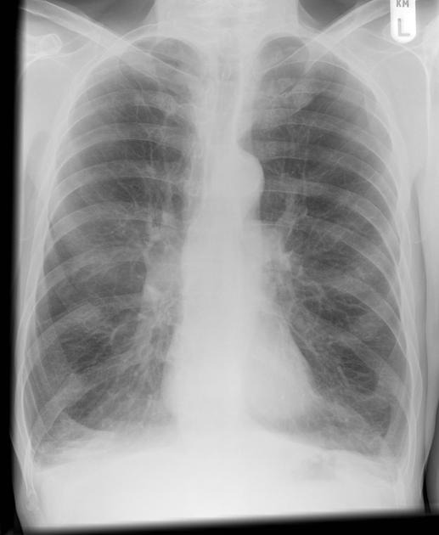
Initial CXR: Increased bronchovascular markings, hyperinflation, flattened diaphragms, and small heart
From Radiopaedia: (https://radiopaedia.org/articles/chronic-obstructive-pulmonary-disease-1)

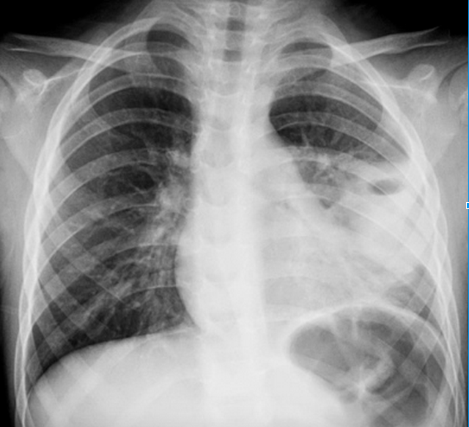
Massive Hemoptysis CXR: Left sided consolidation with increased bronchovascular markings
From FoamCAST: (https://foamcast.org/tag/hemoptysis)
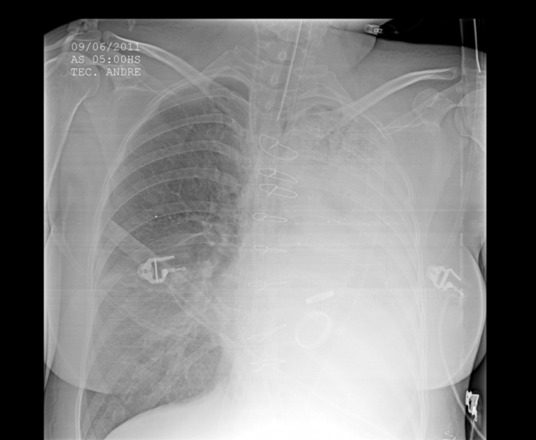
Post-Intubation CXR: Complete left hemithorax with endotracheal tube
From EMDaily: (http://emdaily.cooperhealth.org/content/board-review-critical-care-0)

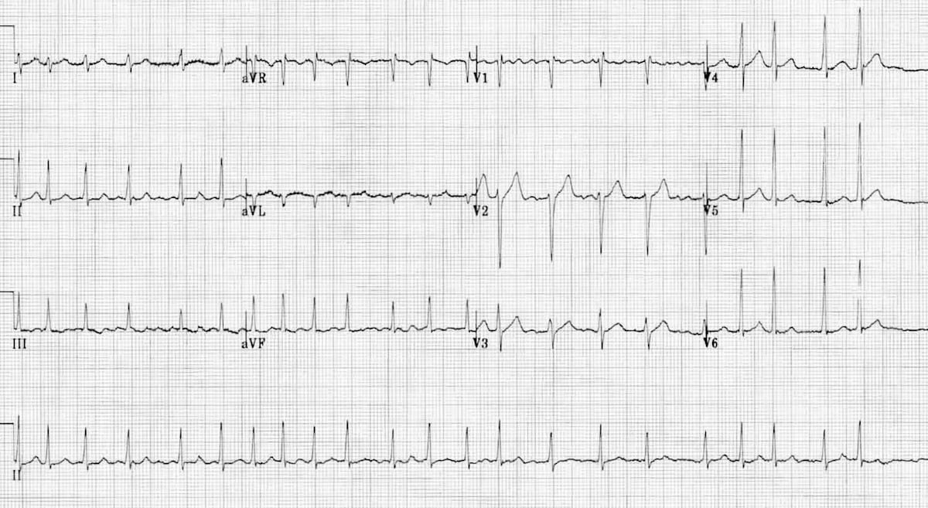
Initial ECG: Atrial Fibrillation with rate ~135 bpm
From Life in the Fast Lane: (https://litfl.com/wp-content/uploads/2018/08/ECG-Atrial-Fibrillation-4.jpg)

Appendix C: Facilitator Cheat Sheet & Debriefing Tips

Include key errors to watch for and common challenges with the case. List issues expected to be part of the debriefing discussion. Supplemental information regarding any relevant pathophysiology, guidelines, or management information that may be reviewed during debriefing should be provided for facilitators to have as a reference.

Key Errors:

1 – Delayed recognition of massive hemoptysis and decompensation
2 – Not reversing bleeding diathesis
3 – Inappropriate positioning or no selective intubation
4 – Delayed consultation to consultants

Debriefing Topics:
1 – Definition of massive hemoptysis
2 – Etiologies of massive hemoptysis
3 – How to distinguish hemoptysis from hematemesis
4 – Airway and securement plan for massive hemoptysis
5 – Appropriate disposition in massive hemoptysis
6 – Review institutional emergency airway management plans
7 – Reversal of warfarin

References

1. Tintinalli J et al. Tintinalli's Emergency Medicine: A Comprehensive Study Guide. Eighth edition. New York: McGraw-Hill Education, 2016.
2. Davidson K, Shojaee S. Managing Massive Hemoptysis. Chest. 2020 Jan;157(1):77-88. Epub 2019 Jul 30. PMID: 31374211.
3. Khatri U, Weiss B. “Massive Hemoptysis”. EM Resident. 2018. https://www.emra.org/emresident/article/massive-hemoptysis/

